**Setup Instructions for PNR Integration with Sabre Red 360**

**and ClientBase Windows v4.06 or higher**

**Follow these setup steps if you are running ClientBase from a local desktop**

# Step 1

Please review system requirements for both [Sabre Red 360](https://agencyeservices.sabre.com/Products/Sabre-Red-360.aspx?documentId=%7bBC1C3A32-3C93-EF0F-8CD5-39329179FA59%7d) and [ClientBase Windows:](http://static.trams.com/tramslibrary/documentation/cb/hwsysrequire.pdf)

(scroll to middle of page, click on Support tab and then click on Technical Requirements)

# Step 2

Verify you have the latest version of ClientBase Windows installed on your server. To download the latest update, open ClientBase Windows on your server, go to **Help > Check for Updates,** and verify that you are on version 4.06.00 build 26 or higher (current version is v 4.08). Alternatively, visit the [Trams Support page](https://www.trams.com/home/support/software_downloads/) to download the latest update.

# Step 3

The new Sabre Red App **CBW PNR Integration** will need to be assigned to each agent’s Sabre EPR. Order and [download](https://www.sabreredappcentre.sabre.com/apps/CBW-PNR-Integration) the CBW PNR Integration App from the Sabre Red App Centre.

***PLEASE NOTE:*** *ClientBase Windows Red App should be ordered after agent is migrated to Sabre Red 360.*

Once the Red App is installed, it will automatically launch with Sabre Red 360. It will not be visible from the Helper App menu, but can be viewed under **Contact Us > Application Vendor Support**

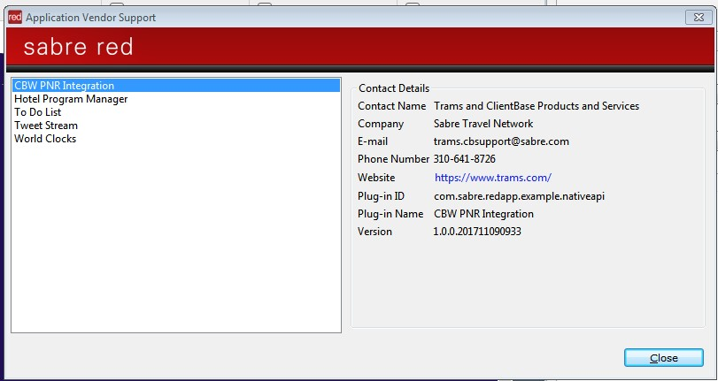

# Step 4

Update API settings in ClientBase Windows using system administrator credentials

**Option A – Use if entire agency has migrated to Sabre Red 360**

**I**f everyone in your agency is migrating to Sabre Red 360 at the same time, please go to **Global Defaults > Merge to PNR Defaults > PNR Settings**

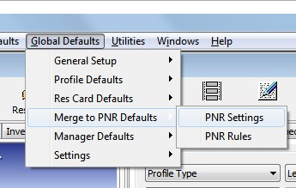

Make sure your GDS selection displays Sabre

Change to “**Use NSRW 3.0 API**” from drop down selection

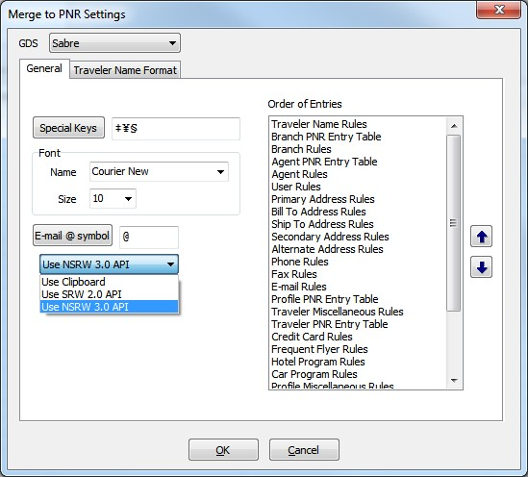

**Option B – Use if only select agents are migrating to Sabre Red 360**

If a limited number of agents are migrating to Sabre Red 360, then API settings must be updated under **Workstation Defaults > Environment** oneach desktop making the move.

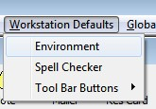

Under **Merge to PNR Settings** tab change the for Sabre drop down selection from Global Setting to “**Use NSRW 3.0 API**”

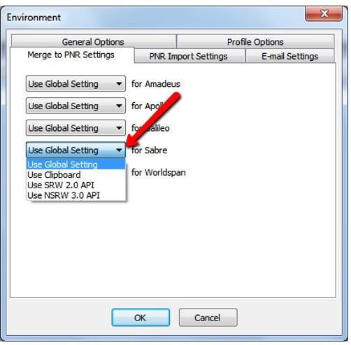

# Under PNR Import Settings, change API drop down selection to “Use Sabre NSRW 3.0 API”

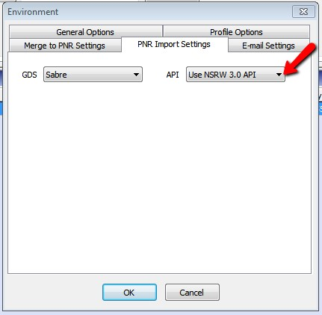

# Step 5

Follow the usual steps in ClientBase for Merge to PNR and PNR Import.

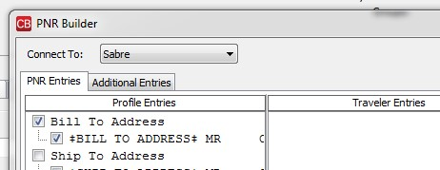

For additional assistance updating or installing ClientBase Windows, please contact our Trams Tech Desk or call 310-641-8726 (press 2 for ClientBase)

For additional support installing Sabre Red 360, please [contact the Sabre Help Desk.](https://eservices.sabre.com/support/swhd/contacts.asp)